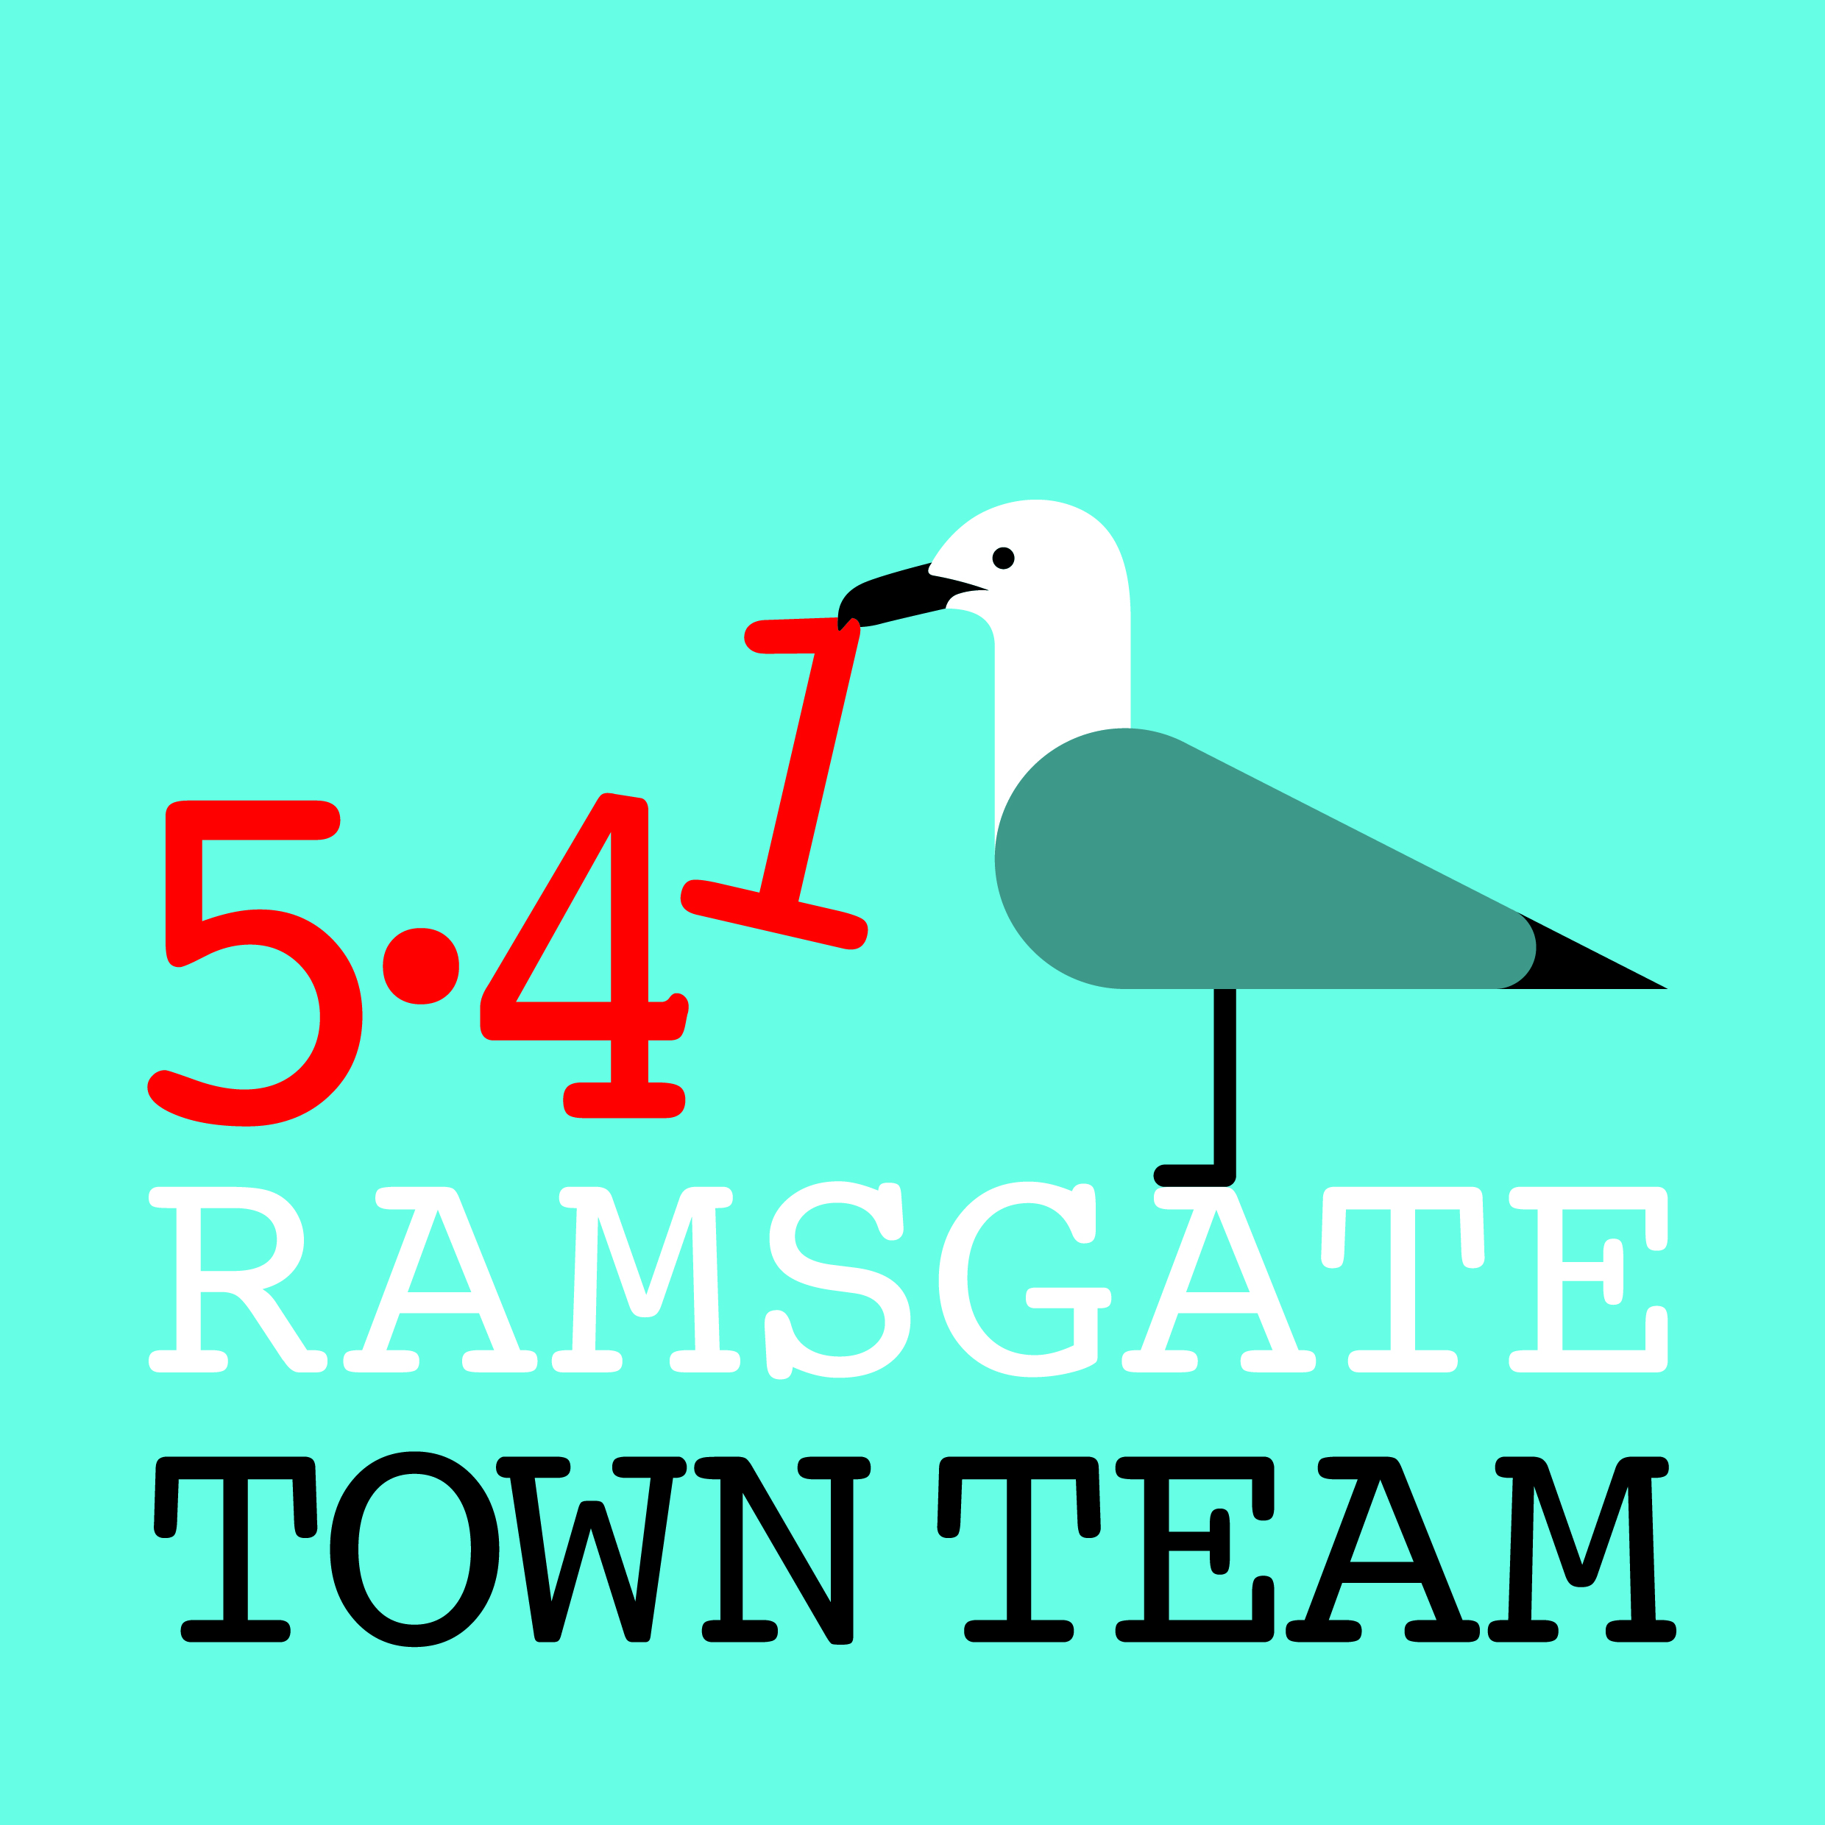
ANNUAL REPORT 2017-18
Ramsgate Town Team exists to help make Ramsgate a great place to live, work and visit. 2017-18 has been a busy, hardworking and generally successful year for the Town Team.
- Harbour Street Working Group
We have work with TDC and KCC this year to improve the streetscape in Harbour Street through actions including painting the bollards, securing repairs to dangerous railings and light fittings, undertaking planting and improving locations of public litter bins.
The temporary No Entry sign has been successful in creating a daytime pedestrian zone, and RTC are now in negotiation with KCC to replace this with a permanent moveable bollard.
Several shops in Harbour St have received shopfront grants and others are in process.
Despite increased police presence, Harbour Street remains a problem area at night. Plans we worked on with TDC last year to start a marshalling scheme do not seem to have progressed. We are in touch with Community Safety colleagues at TDC and continue to press for this.
- Station Working Group
With support from RTC’s Ramsgate Fund, and in partnership with SouthEastern Rail, we have installed 14 granite planters at the front of the station planted up with seasonal plants, including some spring bulbs, which are attracting positive comments (though sadly they are also attracting cigarette ends, despite the new ashtrays at the front of the building!)
The planting complements SouthEastern’s refurbishment of the station building – and we are pleased to see we made it into Simon Jenkins’ recent ‘Britain’s 100 Best Railway Stations’!
Our new leaflet holder in the Booking Hall is well used and staff have been helpful in restocking it with leaflets. A wayfinding sign in the Booking Hall is also planned (see below).
- Ramsgate ROAD (Ramsgate Residents One A Day)
Our litter-picking group launched in September and now has 380 members, and has generated its own momentum, with action taken to address commercial waste problems, more reporting of fly tipping and related issues, and plans in train to set up a street / neighbourhood litter monitoring scheme. A meeting with TDC is planned for mid-March to establish a joint Council/community steering group to tackle litter and waste issues in Ramsgate.
- Wayfinding Working Group
This RTT subgroup now operates primarily via the Coastal Communities Team. Funding from TDC has finally been received, a tender process undertaken and signage specialists Fitzpatrick Woolmer from Rochester commissioned to provide 4 monoliths, including one in the Station Booking Hall, with direction finding information from the Station into town, and 12 finger posts marking primary destinations. It is hoped this work will be completed by the summer.
We are concerned that current wayfinding plans do not appear to include any finger posts on the East Cliff. We would not wish this side of town to be overlooked when signage is planned, and are currently in discussion with the Coastal Communities Team about this.
- Events Working Group
The town centre Christmas Switch On event 2017 was very well attended. The land train, Santa’s Grotto and the snow globe remain extremely popular. The lantern parade, led by Santa, was a highlight for the children who had been creating their lanterns.
We are currently working on the town centre’s Easter celebrations, which have an Alice in Wonderland theme. A huge White Rabbit model created by local artist Janice Gibbs will lead the Easter parade, and hat-making workshops are now taking place at AiR.
- Shopfront Grants
We have given grants to improve a number of town centre shopfronts this year, including Nice Things, The Surin, Nanny’s Attic, Arthur Barber’s, Amber Rose and the Home Front café. We are planning a joint effort with the owners to refurbish the exterior of the Harbour Fish Bar shortly, which we hope will have a positive impact on the gateway to the town.
Under our proposed charitable status, we will not be able to give grants to commercial premises, but could use non-charitable funding for this, so this is under discussion.
- Partnership Work
Funding: Reps from the TT and other groups went together to a Funding for All event in Whitstable in October and established a joint Dropbox folder to share funding information. We have now set up a Ramsgate Funding Forum Facebook page, which is about to launch.
Advocating for Ramsgate: The TT has joined its voice to those of RTC and Ramsgate groups in pressing for improvements, responding to consultations (eg on Manston) and challenging decisions that disadvantage Ramsgate (eg TDC’s decision to increase parking charges).
The Town Team has also supported other groups’ work during the year, including the Surfers Against Sewage Plastic Free Coastlines campaign, FORS for East Kent College’s Community Day, the RNLI’s Sea Safety Day, the Ramsgate Society’s cleaning of the Victorian shelters (and part-funding CCTV to try to reduce vandalism). We are part of inter-agency groups including the Neighbourhood Planning Group and Craig Mackinlay’s Ramsgate Regeneration Alliance.
- Charitable Status
The Town Team has applied to the Charity Commission for Foundation Charitable Incorporated Organisation (CIO) status. We have received invaluable support on this from Funding for All, a KCC-funded body working with voluntary organisations across Kent, who have helped us to reframe our constitution to fit legal requirements for charitable bodies. Our application and constitution were approved at two Special General Meetings held in December and February.
- Membership/ Executive Committee Membership
40 people have signed up as members of the Town Team: however, the Town Team’s base of support is much wider – for example, we have 380 volunteers in the Ramsgate ROAD group, 1880 likes on Facebook and over 2000 on Twitter. All members are encouraged to tell their friends about the Town Team and encourage them to sign up as members.
Executive Committee: Executive Committee members for 2017-18 have been:
Rebekah Smith (Chair) Richard Styles Jo Hanchett (Vice Chair) Madeline Wright
Tricia Hartley (Secretary) Fiona Simmons Maria Gavin (Treasurer/ Membership) Pat Makinson
Sue Hall All members of the Committee are willing to stand for re-election for 2018-19.

- Plans for 2018-19
Ramsgate Recyclists Project: The TT hopes to establish a refurbishment workshop for bikes and household goods, providing a training facility for young people and allowing us to set up a bike hire scheme from Ramsgate Station in partnership with SouthEastern. This will obviously require substantial funds, but we expect to have better chances of securing this as a charity.
Town Centre Refurbishment: We plan to continue our town centre refurb programme, and will be asking for bollard-painting volunteers soon! We also hope to revive our earlier plans to decorate the risers on Kent Steps with Pugin-style tiles designed by local art tutors & students.
Parades: We hope to run more crafting workshops and parades through the year, following the success of the Christmas lantern parades, involving a wider range of families by offering tutors for after school clubs and community centres, and creating 'making kits' that schools can give out, with step by step photo tutorials and Youtube video links.
Litter and Waste Management: As mentioned above, we are working with TDC and the Ramsgate Society to pull together a steering group to co-ordinate anti-litter and waste management initiatives in the town, including a possible street/ area-level monitoring scheme.
5.41 Scheme: If we secure charitable status, we plan to launch our 5.41 fundraising campaign, whereby individuals and businesses can donate £5.41 per month to support our work.
Website: We also hope to undertake a tender process to set up an independent RTT website.
We are grateful for the support of all the Town Team’s members, and will be delighted to take on board additional suggestions for our future work programme from members and friends.

A few visual highlights from Ramsgate Town Team’s year
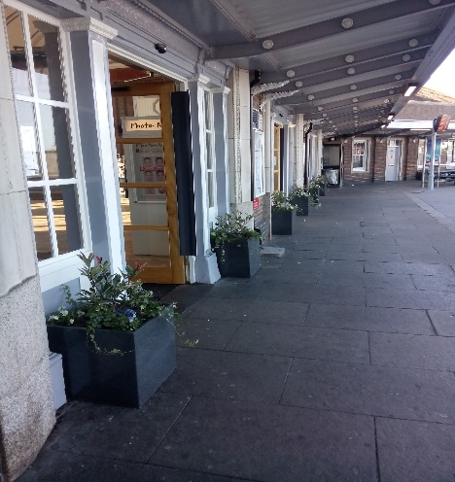  Ramsgate Station frontage | Station planter detail  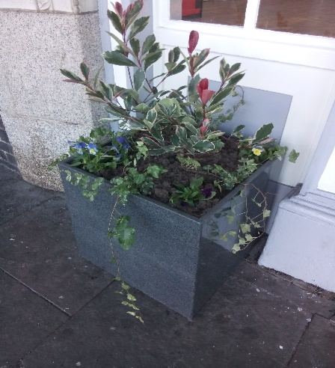 | Town Centre events  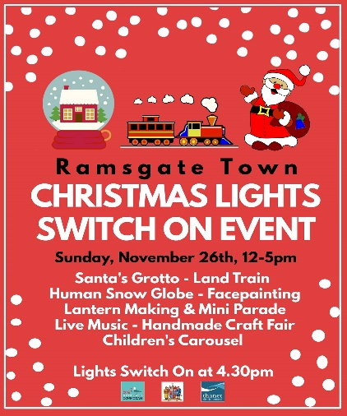
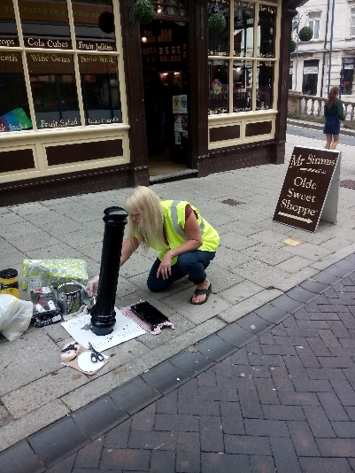  Painting in Harbour St | One of the dangerous posts removed from Harbour St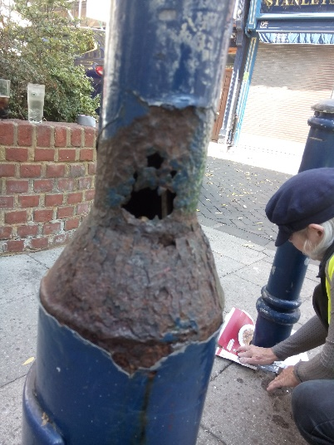 | 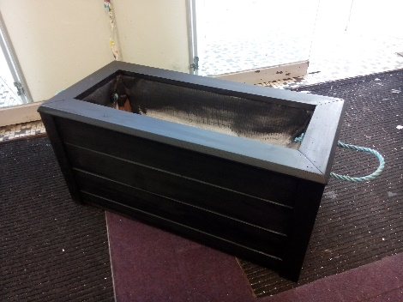  Harbour St planters, made by local carpenter Kevin Cromeeke
Victorian tram shelter – before and after  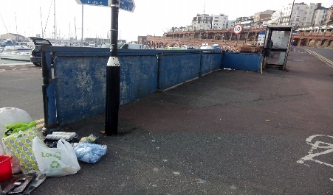  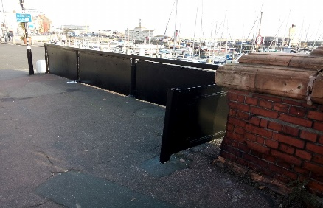 | Shopfront grants  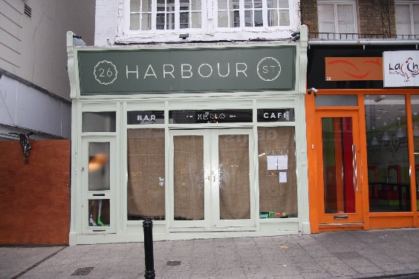  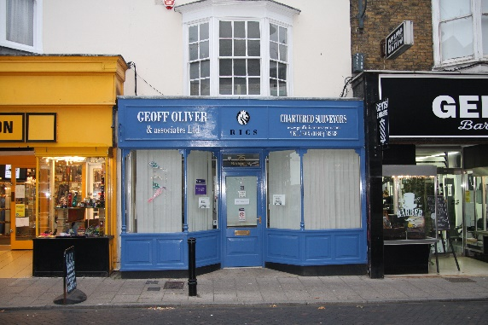 | 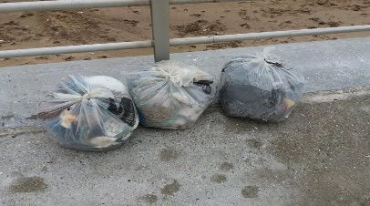  Ramsgate ROAD group:  380 people x 365 days = 138,700 fewer pieces of litter each year!  